**EPM - UAT PROCESS FLOW DOCUMENT**

**For**  


**Consulting Partner:**

  
**AstroWix India Project Solutions Pvt. Ltd.**

**A- 4&5, Logix Park**

**Sector 16, Noida - 201301, India  
Phone: + 91-120 – 4033-854**

**Fax: +91 120 531 5766**

**E-mail:**[**info@astrowix.com**](mailto:info@astrowix.com)

**Website:**[**www.astrowix.com**](http://www.astrowix.com)

**Consulting Partner:**

  
AstroWix India Project Solutions Pvt. Ltd.

A- 4&5, Logix Park

Sector 16, Noida - 201301, India  
Phone: + 91-120 – 4033-854

Fax: +91 120 531 5766

E-mail:[info@astrowix.com](mailto:info@astrowix.com)

Website:[www.astrowix.com](http://www.astrowix.com)

**UAT Process Flow Document – EPM Deployment**

**Last Updated:**

**18 June 2009**

Table of Content

Process Flow Diagram 3

Planning Process 4

1. Project Manager Role – Create the Project plan 4

Resource Allocation 10

1. Resource Manager Role – Allocating the Resources 10

2. Project Manager Role – Verify and validate the project plan with replaced resources 13

execution process 17

1. Team Member Role – Update progress update 17

2. Project Manager Role – Approve resource assignments 19

3. Team Member Role – Verify approve status 21

4. Project Manager Role – Verify the approved status on MS project 22

Rework process 24

1. Team Member Role – Add the rework activity 24

2. Project Manager Role – Approve resource rework assignments 26

3. Project Manager Role – View and validate the rework activity 28

Sign-off Sheet 29

# Process Flow Diagram

# Planning Process

## **1. Project Manager Role – Create the Project plan**

### [**CONNECT MS Project (log on) to Project Server**](http://office.microsoft.com/search/redir.aspx?AssetID=HA100378441033&CTT=5&Origin=HA102506121033)

1. On the Windows taskbar, click the Start button.
2. The Start menu appears.
3. On the Start menu, point to Programs, click Microsoft Office, and then click Microsoft Office Project 2007.
4. Notes: Depending on how your enterprise options have been set in Project Professional, you might be prompted to log into or choose a Project Server account.



If the Login dialog box appears, select User Profile from Drop Down box, and then click OK.

### **Publish Project plan with appropriate Template**

1. Click on File
2. Click on New

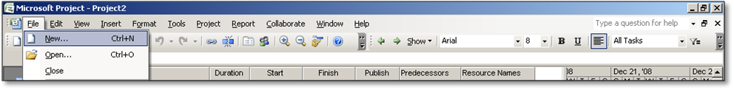

1. On My computer

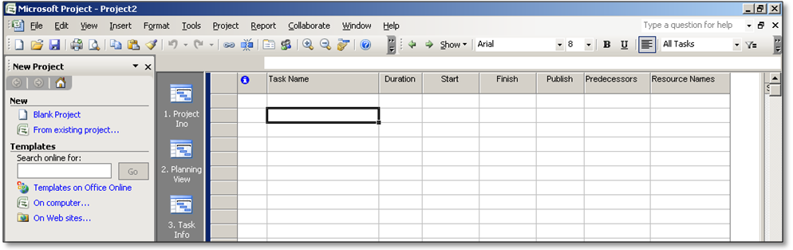

1. Select Enterprise Template
2. Click on Template
3. Select the Project level Attribute.

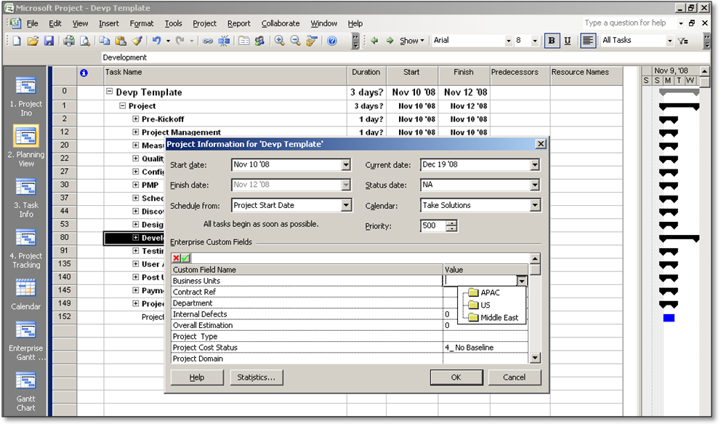

1. Select Tool -> Build Team From Enterprise

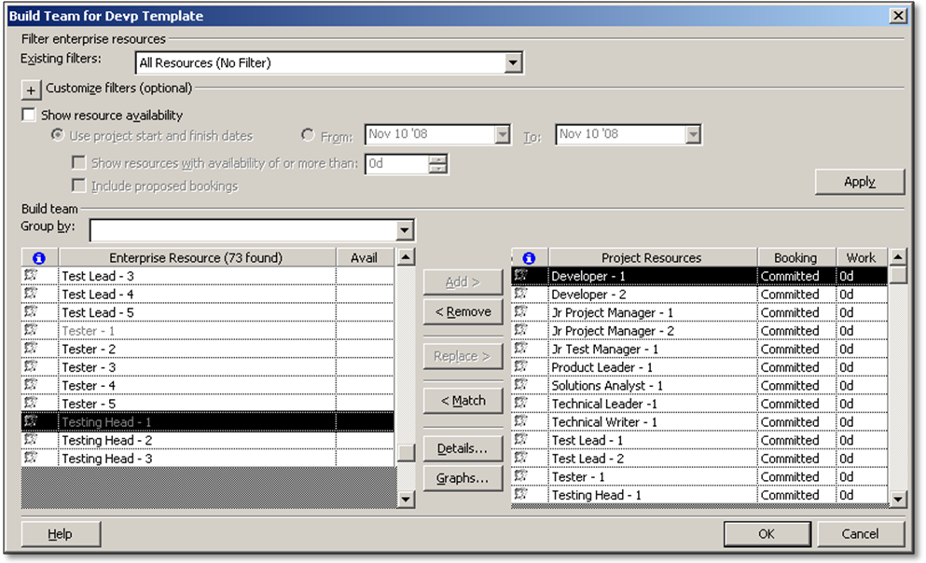

1. Select the Generic Resource as required to for the Project Team
2. Estimate the Effort, Established the Logical Dependency between the task, and Assign the required resource to performed the task

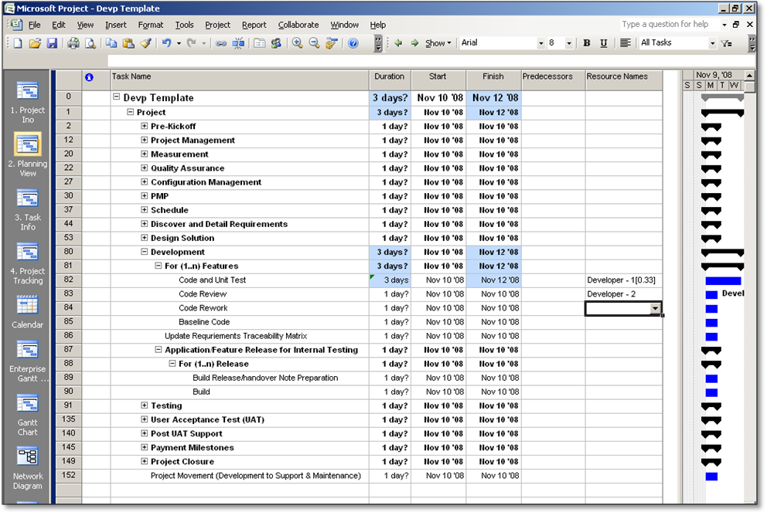

Effort Estimation

Assign **Generic Resource** or **Actual Resource**

Create the logical Dependency

1. Click on Task Info View to provide the task information

**Note:** Select the Task with appropriate information such as:

Task belongs to which phase,

Task type,

Billable or Not,

EED % : Estimate Effort Distribution,

ESD % : Estimated Schedule Distribution % at Summary level,

Defect Density Distribution %

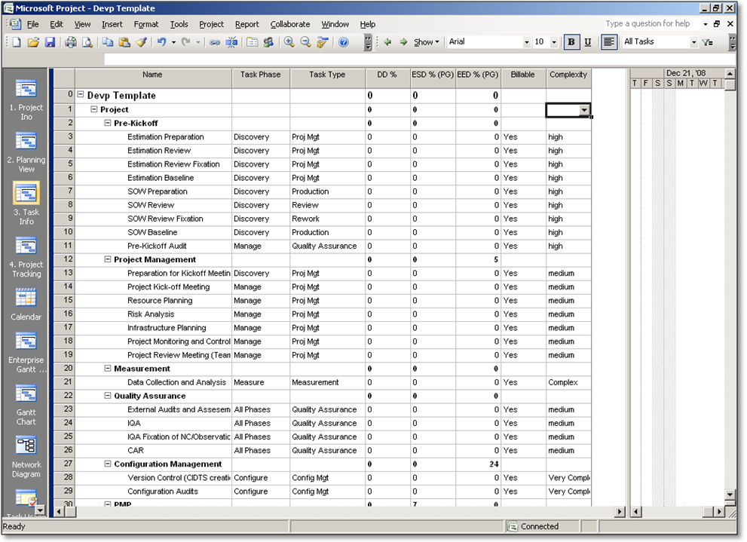

Provide the task level information

1. Task Phase
2. Task Type
3. Defect Distribution
4. Estimated Schedule Distribution
5. Estimated Effort Distribution
6. Billable
7. Complexity of task
8. Once the Resource Assignment, Effort Estimation, Task level information has been provided project has to save the project on the server
9. Publish the project on the server with Specific Naming Convention

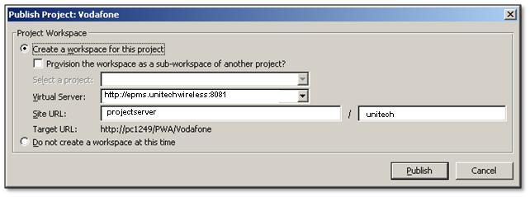

**Workspace URL**

**Note**: Once the project publish on the server, it will ask to project manager to create the associate the project workspace on server where Project Team log the Issue, Risk, Associate project document

1. Click Publish

### **Working with Project Workspace**

* 1. Access the URL as <http://epms.unitechwireless:8081/projectser>ver

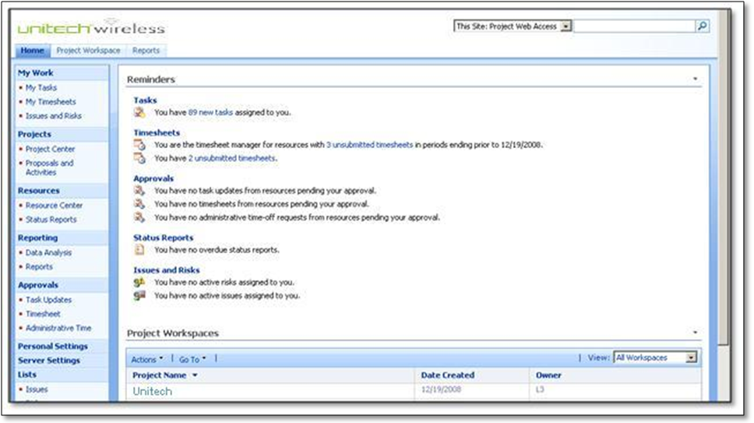

**Quick Launch**

**Project Workspaces**

**Reminders Section**

* 1. Click on project Workspace for specific project

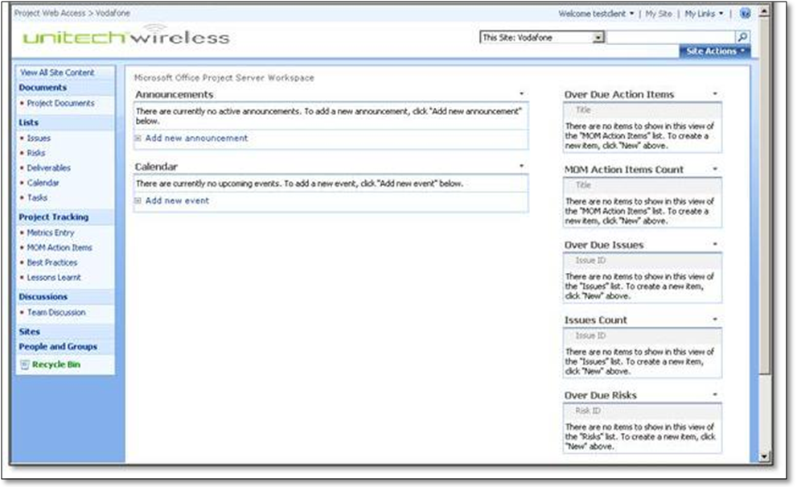

# Resource Allocation

## 1. Resource Manager Role – Allocating the Resources

1. Access the URL as <http://epms.unitechwireless:8081/projectserver>



1. Click on project Center View on Quick Launch bar

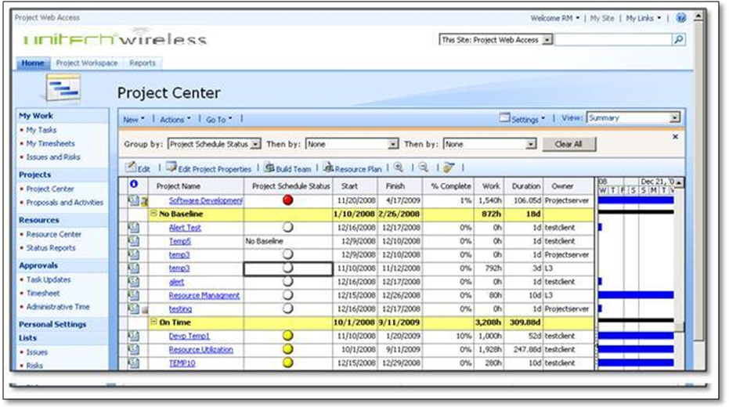

1. Select the appropriate project from the list of the project to use the Build team to allocate the resource.
2. Click on the Build Team
3. View the Left hand side as the enterprise resource and Right has assigned generic resource

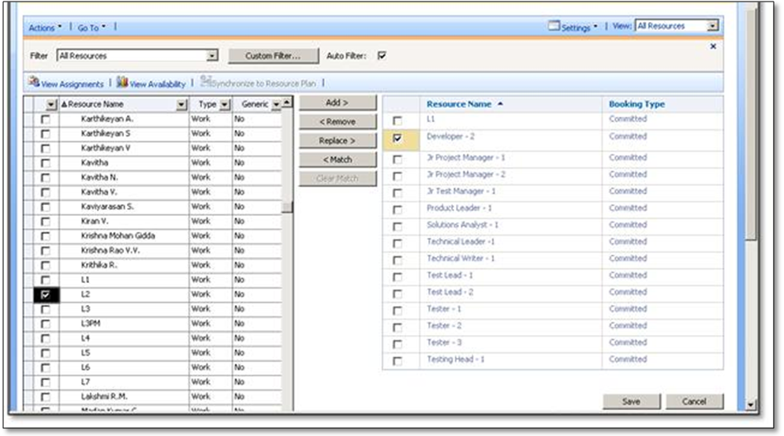

**Enterprise Resources**

**Project Resources**

1. Select the generic resource and click on Match

Note: On the Role wise segregation appropriate resource comes in list.

1. Select the Generic as well as the enterprise resource to view the availability of the actual resource on specific period of the time

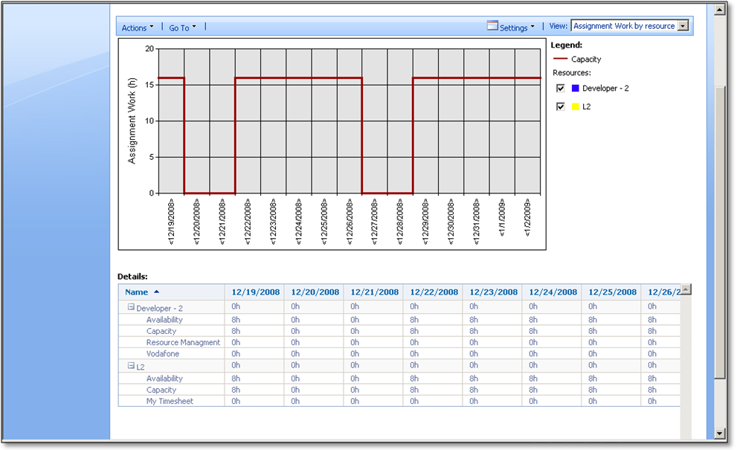

**Resource Assignment Table**

1. Select the Actual resource and Generic Resource to replace

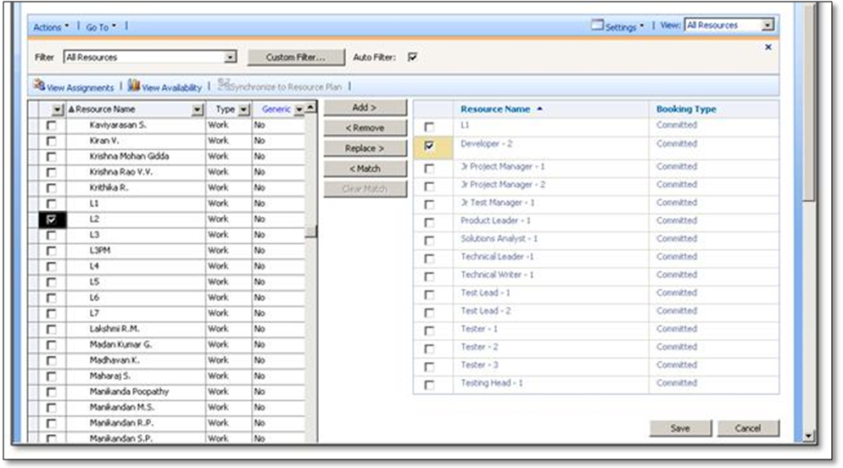

1. Same has to be Done for all the resources

**Note:** If the project Manger is unable to provide the resource at specific resource Manager is also able to allocate the resource and after that project manager assign the resource on the relevant activities.

1. Click on Save

## 2. Project Manager Role – Verify and validate the project plan with replaced resources

### [**Connect MS Project (log on) to Project Server**](http://office.microsoft.com/search/redir.aspx?AssetID=HA100378441033&CTT=5&Origin=HA102506121033)

1. On the Windows taskbar, click the Start button.
2. The Start menu appears.
3. On the Start menu, point to All Programs, click Microsoft Office, and then click Microsoft Office Project 2007.
4. Notes: Depending on how your enterprise options have been set in Project Professional, you might be prompted to log into or choose a Project Server account.



1. If the Login dialog box appears, select User Profile from Drop Down box, and then click OK.

### [**Verify the in Replaced resource in MS Project**](http://office.microsoft.com/search/redir.aspx?AssetID=HA100378441033&CTT=5&Origin=HA102506121033)

1. Click on file
2. Open or Ctrl +O
3. Click on Retrieve the project on project server
4. Click the specified project on Read/Write mode
5. Verify the resource assignment

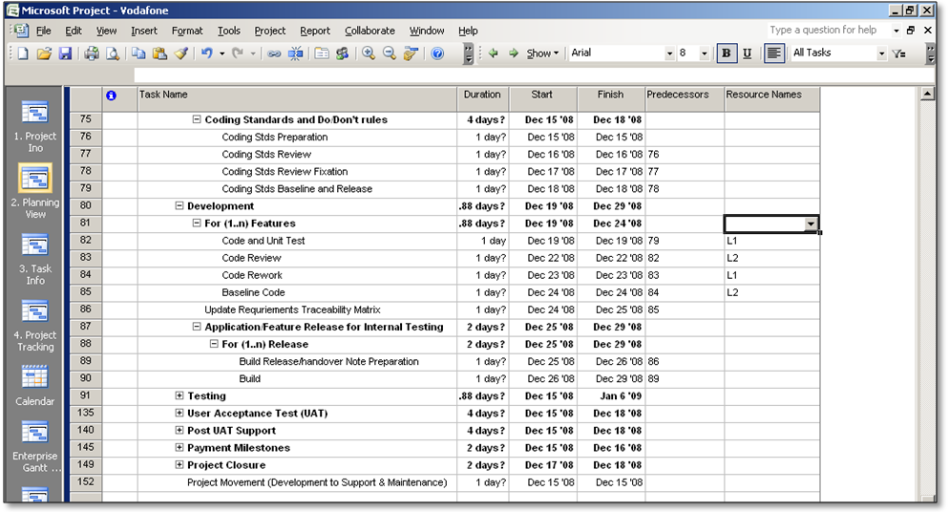

1. Once again verify the Project Schedule
2. Once it get finalize Save the Baseline ->Took ->Tracking ->Set Baseline

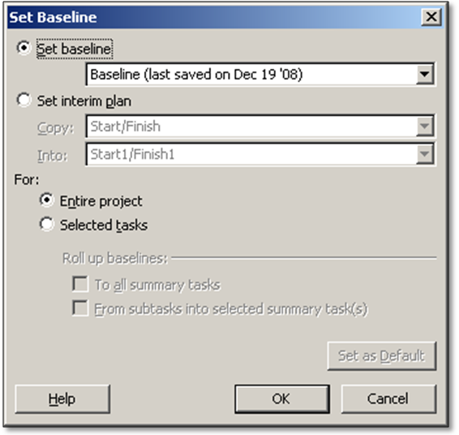

1. Save and publish the project

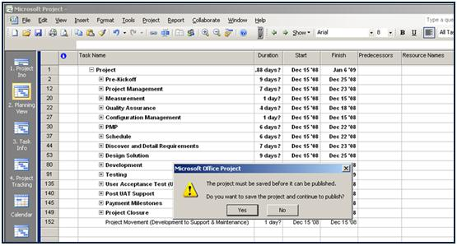

1. View the project in project Center with project level information on specified Reports/View in Project Center

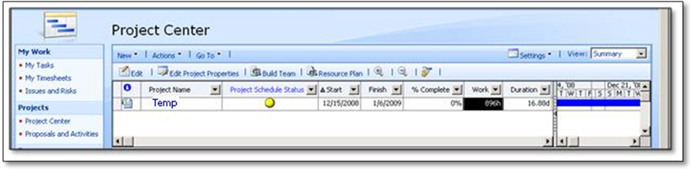

# execution process

## 1. Team Member Role – Update progress update

1. Access the URL as <http://epms.unitechwireless:8081/projectserver>

View the remainder against newly assigned task

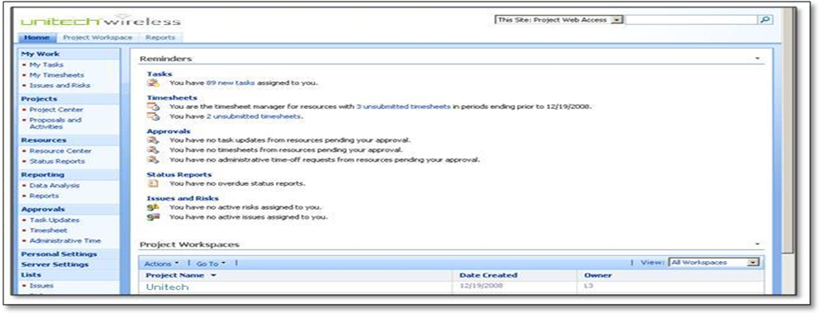

1. Click on My task

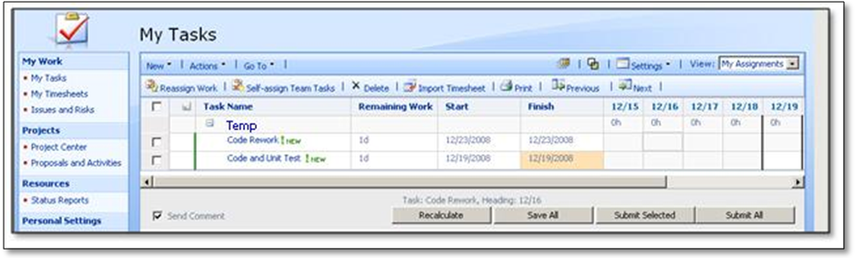

Current Date

Current Task Information

**Notes:** As per the Task and Display setting appropriate task has been visible on the my task pane

1. In execution phase project team update the project or Task Progress using their respective user log

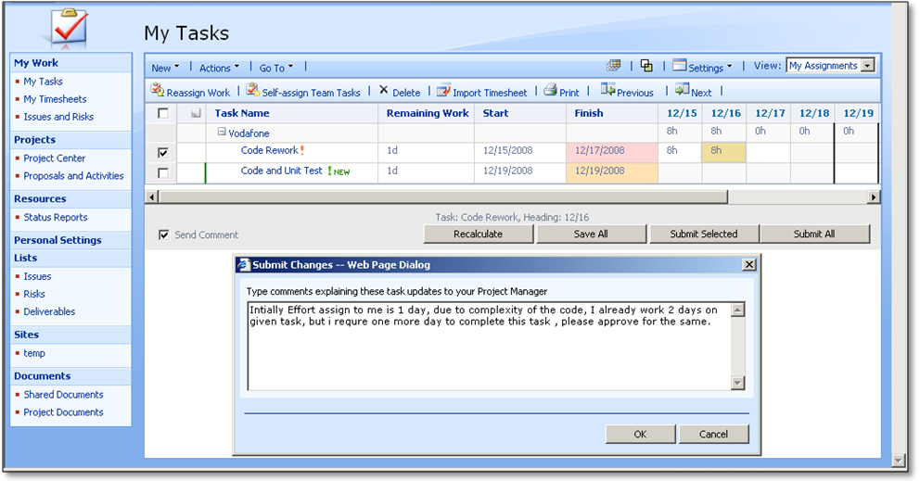

1. Task has been updates with respective transaction comment
2. Appropriate task goes for approval to their respective project manger

## 2. Project Manager Role – Approve resource assignments

1. Access the URL as <http://epms.unitechwirelss:8081/projectserver>

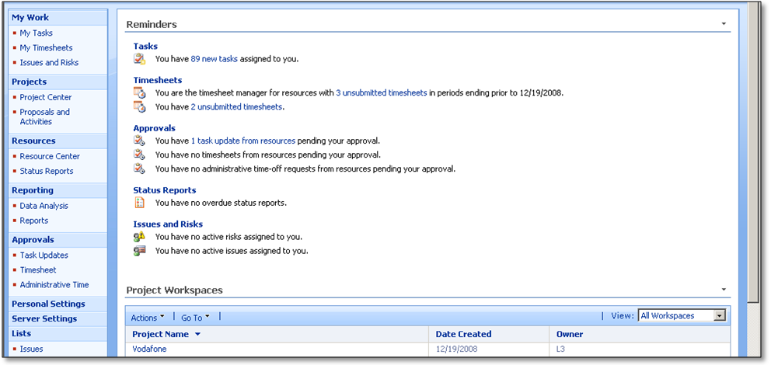

Once the team member updates the task progress it comes to the project manager for approval

1. Click on the task update from approval section on Quick launch

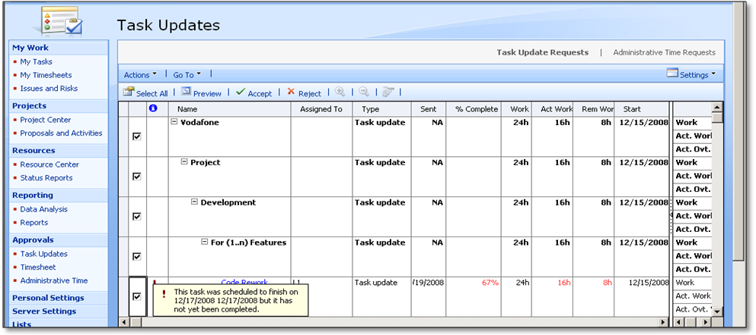

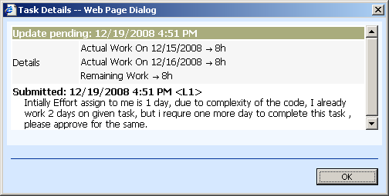

1. View the impact analysis on duration, previous start and previous finish

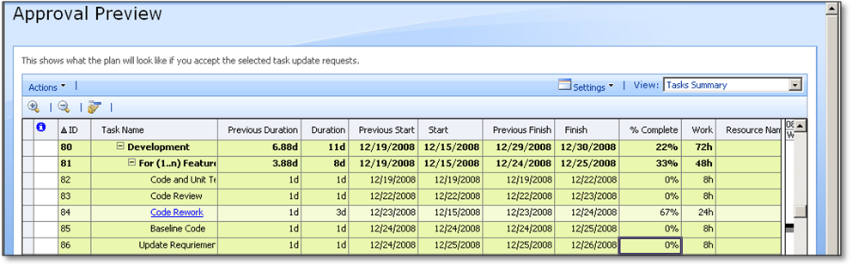

Impact Analysis with in terms of Duration, Start and Finish Date

1. Approve the resource progress assignment

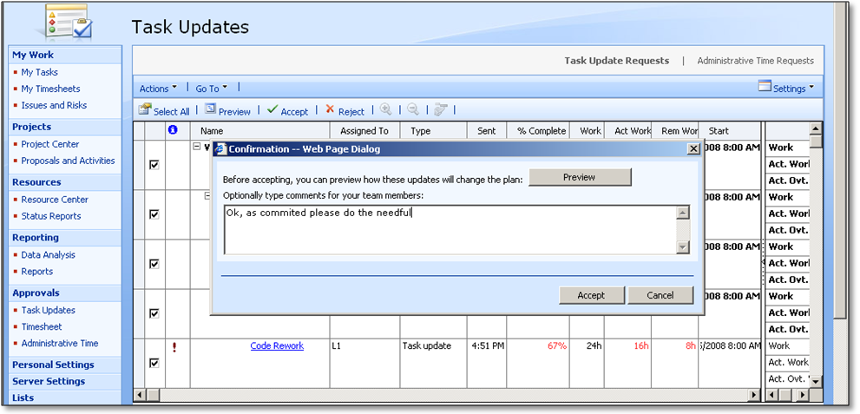

## 3. Team Member Role – Verify approve status

### [**View and validate the approved status by team member**](http://office.microsoft.com/search/redir.aspx?AssetID=HA100378441033&CTT=5&Origin=HA102506121033)

1. Access the URL as Access the URL as <http://epms.unitechwirelss:8081/projectserver>
2. Click on the My Task to verify the assignment get updated by team member

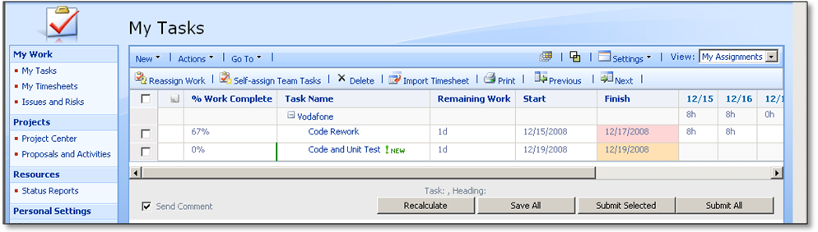

1. Once the project manager approve the assignment status it get reflect the respective team member assignment section

## 4. Project Manager Role – Verify the approved status on MS project

### [**Connect MS Project (log on) to Project Server**](http://office.microsoft.com/search/redir.aspx?AssetID=HA100378441033&CTT=5&Origin=HA102506121033)

1. On the Windows taskbar, click the Start button.
2. The Start menu appears.
3. On the Start menu, point to All Programs, click Microsoft Office, and then click Microsoft Office Project 2007.
4. **Notes**: Depending on how your enterprise options have been set in Project Professional, you might be prompted to log into or choose a Project Server account.
5. **To verify the** approved status same get reflected in MS project file

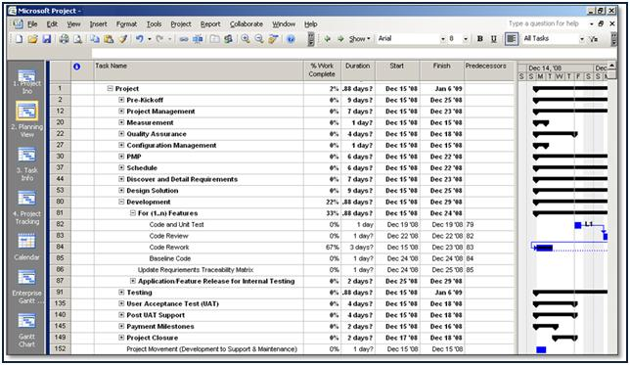

Team Member assignment get updated on the MS Project

1. Same need to publish by project manager to create the variance report and top executive



# Rework process

## 1. Team Member Role – Add the rework activity

### [**Create the rework activities by the team member**](http://office.microsoft.com/search/redir.aspx?AssetID=HA100378441033&CTT=5&Origin=HA102506121033)

1. Access the URL as Access the URL as <http://epms.unitechwirelss:8081/projectserver>
2. Click on the my task
3. Click on New
4. Add the rework assignment on existing project plan

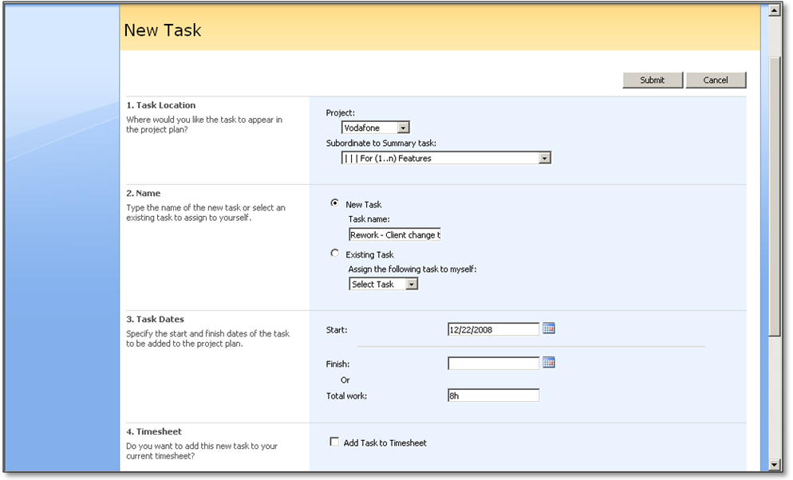

1. Select the project to add the activity
2. Select the project phase to add the activity
3. Define the name of the activity
4. Provide the Start date and effort estimation to complete the activity
5. Submit the task
6. Submit the task to approval to project manager

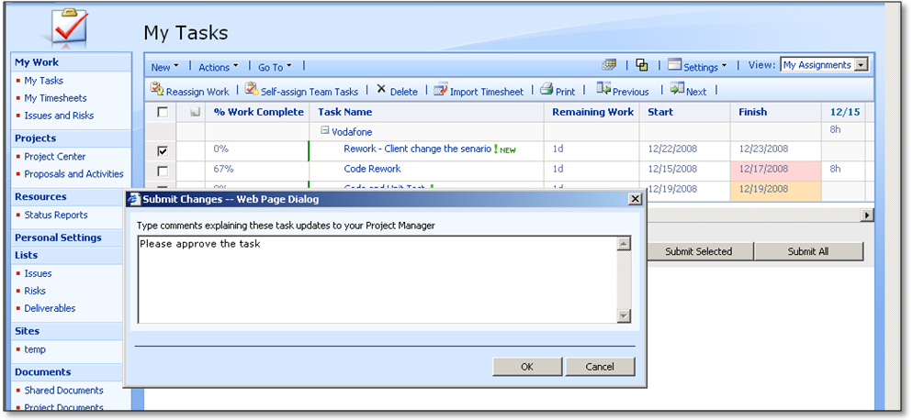

1. Task send to project manager for approval

## 2. Project Manager Role – Approve resource rework assignments

* 1. Access the URL as Access the URL as <http://epms.unitechwirelss:8081/projectserver>



Once the team member add the task to create the rework activity it will goes to the respective project manager for approval

* 1. Click on the task update from approval section on Quick launch

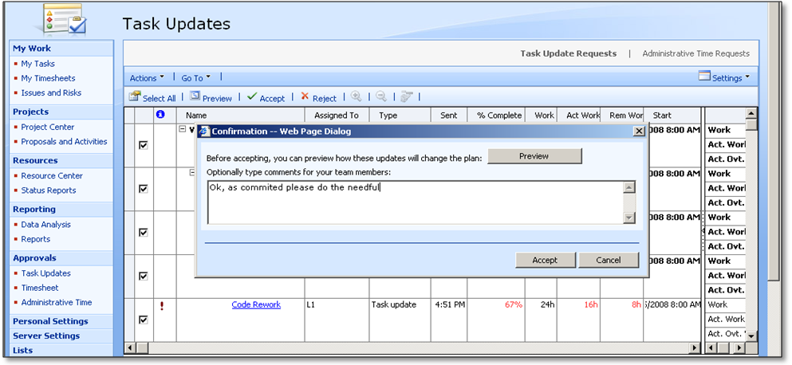

1. View the impact analysis on duration, previous start and previous finish
2. Approve the resource rework assignment

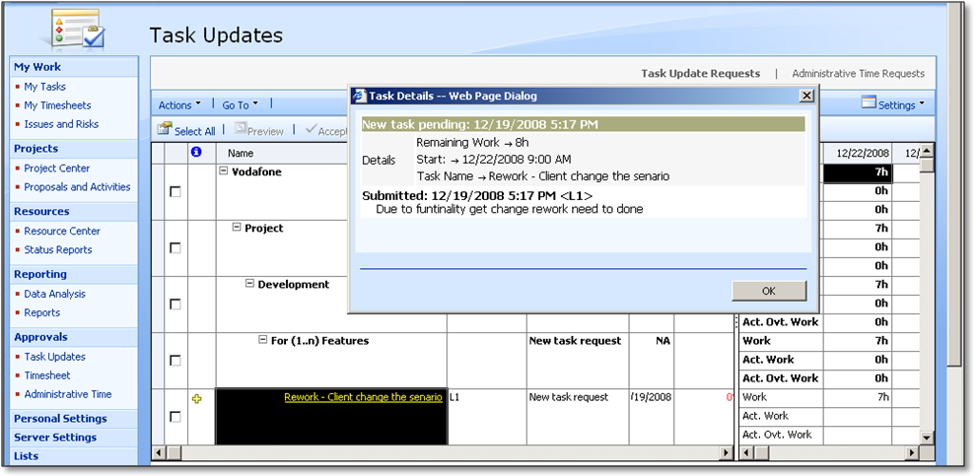

## 3. Project Manager Role – View and validate the rework activity

1. Log in MS project
2. Open the project from enterprise
3. Click the retrieve the project from project server
4. Open the respective file
5. **To** verify the rework activity incorporated in project plan



Rework Assignment incorporated on the Project Plan

1. once verify project need to save on the project server
2. click the save and publish the project plan on the server

# Sign-off Sheet

**This UAT is hereby approved as follows:**

Name: _______

Role:

Company Stamp/ Seal

Signature:

Date: _______

Name: _______

Company Stamp/ Seal

Role:

Signature:

Date: _______

Name: _______

Company Stamp/ Seal

Role:

Signature:

Date: _______